npm registry

🌐 What Is the npm Registry?
# Source: AI Source: Provided by: [Data Path: Persons Table -> ID Column: 1, Name_En Column: Motasem Essam] -> From: [Chatgpt (GPT‑5 Mini)] on [1/26/2026]
The npm registry is a public online database (like a library or store) that contains over 2 million JavaScript packages (also called modules). These packages can be downloaded, shared, and managed using the npm CLI (command-line interface).

✅ Simple Definition:
# Source: AI Source: Provided by: [Data Path: Persons Table -> ID Column: 1, Name_En Column: Motasem Essam] -> From: [Chatgpt (GPT‑5 Mini)] on [1/26/2026]
The npm registry is where npm stores and retrieves JavaScript packages — it's like the “app store” for Node.js projects.

📦 Official URL:
# Source: AI Source: Provided by: [Data Path: Persons Table -> ID Column: 1, Name_En Column: Motasem Essam] -> From: [Chatgpt (GPT‑5 Mini)] on [1/26/2026]
You can browse it at:
👉 https://www.npmjs.com

🔧 What You Can Do with It:
# Source: AI Source: Provided by: [Data Path: Persons Table -> ID Column: 1, Name_En Column: Motasem Essam] -> From: [Chatgpt (GPT‑5 Mini)] on [1/26/2026]
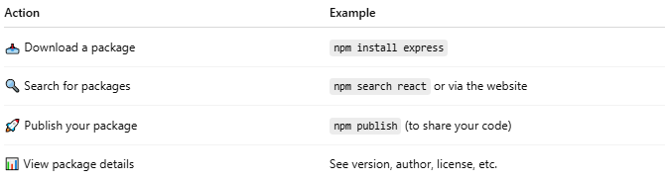

Action | Example
📥 Download a package | npm install express
🔍 Search for packages | npm search react or via the website
🚀 Publish your package | npm publish (to share your code)
📊 View package details | See version, author, license, etc.

📁 Example Package (like axios):
# Source: AI Source: Provided by: [Data Path: Persons Table -> ID Column: 1, Name_En Column: Motasem Essam] -> From: [Chatgpt (GPT‑5 Mini)] on [1/26/2026]
Visit: https://www.npmjs.com/package/axios
You’ll find:
- Description of the library
- Installation command
- Version history
- Dependencies
- README documentation

🔒 Public vs Private
# Source: AI Source: Provided by: [Data Path: Persons Table -> ID Column: 1, Name_En Column: Motasem Essam] -> From: [Chatgpt (GPT‑5 Mini)] on [1/26/2026]
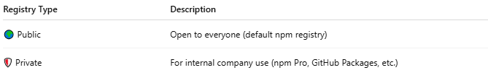
Registry Type | Description
🌍 Public | Open to everyone (default npm registry)
🛡️ Private | For internal company use (npm Pro, GitHub Packages, etc.)

📌 Summary
# Source: AI Source: Provided by: [Data Path: Persons Table -> ID Column: 1, Name_En Column: Motasem Essam] -> From: [Chatgpt (GPT‑5 Mini)] on [1/26/2026]
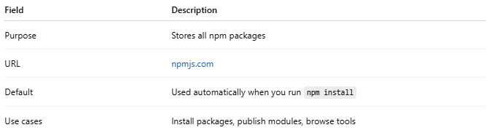

Field | Description
Purpose | Stores all npm packages
URL | npmjs.com
Default | Used automatically when you run npm install
Use cases | Install packages, publish modules, browse tools

